**Mission**

At Rotten Tomatoes, one of our most popular pages is the movie details page. We want you to build a really simple one for us!

**Requirements**

1. Create a web server using Node.js to handle an incoming http request to http://localhost:8080/movies/771373077
   1. Create a GET route handler for “/movies/:movieid” (it only has to work with movie id “771373077” for this assignment)
      1. Use the “Movie Details” data source (details below) to get all movie data
      2. Render an HTML page (details in the next step) using this movie data
2. Create a web page to display movie information
   1. Implement a Desktop view and Mobile view, following the comps at the end of this document
   2. Use the image assets that are linked below (a separate Google Drive zip file)
   3. Use the “Article” data source to get data and create the article carousel
      1. Create thumbnails linking to the article page
      2. Clicking the Next (>) button will shift the carousel forward 4 slides
      3. Clicking the Back (<) button will shift the carousel backwards 4 slides

**Guidelines**

1. Use only vanilla javascript and vanilla css! (no TypeScript, CoffeeScript, LESS, SASS, etc)
2. You may use server-side framework (Express, Hapi, Koa, etc)
3. No front-end framework (such as Angular, Ember, etc)
4. No third-party libraries (such as jQuery, React, bootstrap, foundation, underscore, etc)
5. No build, no bundle, no css preprocessor (such as Webpack, Grunt, Gulp, etc)
6. We love to see nicely organized code
7. Use your favorite or most familiar design and architectural patterns
8. This assessment shouldn’t take more than a few days to complete

**Data Sources**

1. Articles:

<https://s3-us-west-2.amazonaws.com/take-home/take-home-articles.json>

1. Movie Details:

<https://s3-us-west-2.amazonaws.com/take-home/take-home-movie.json>

**Image Assets**  
<https://drive.google.com/file/d/0B3VstP3xuLRTUVk2dVJIeF9uM2c/view?usp=sharing>

**Deliverables**

* Submit all files or a link of your work to us at [engineering@rottentomatoes.com](mailto:engineering@rottentomatoes.com) with instructions on how to run your site!

**Desktop View:**

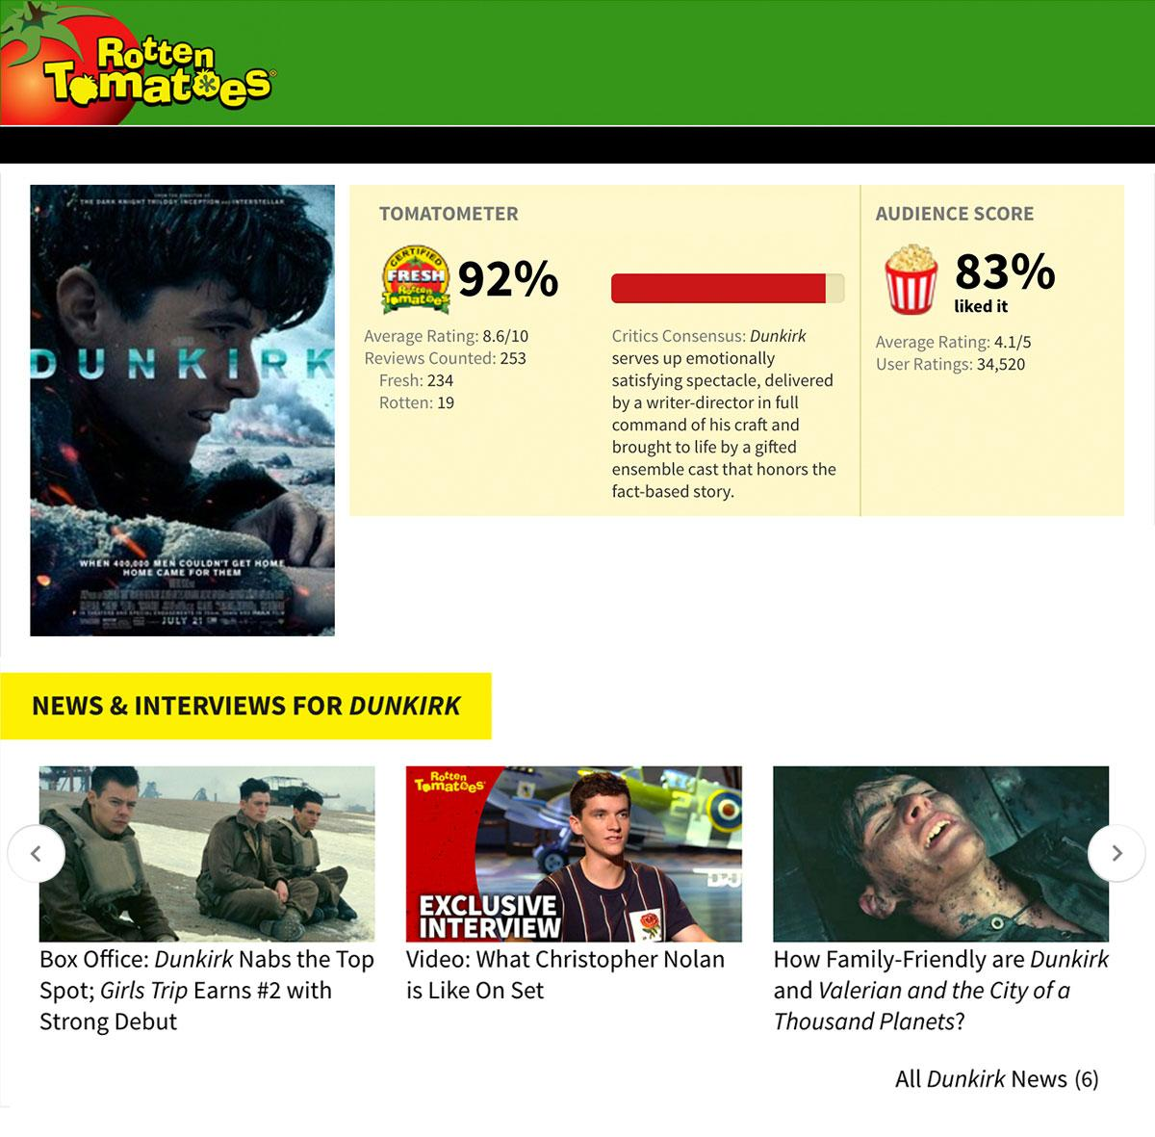

**Mobile View (768px wide or less):**

